**MAIN FIGURES**

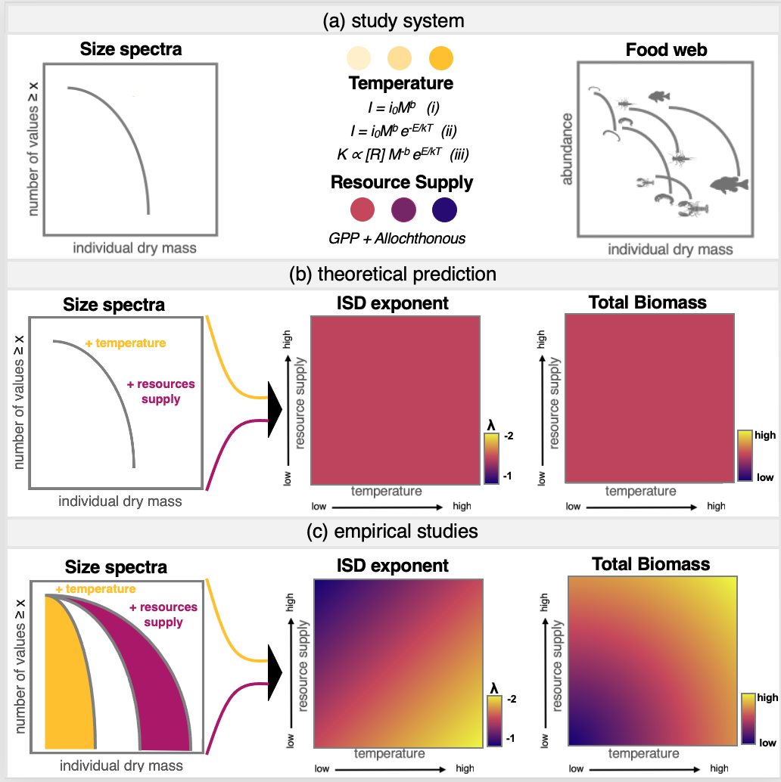

Figure X. Conceptual model of the scaling of size spectra and standing stock biomass with temperature and resource supply. Temperature is the most commonly studied driver of mass scaling, but resource supply is fundamental to scaling theory as well. Due to interactions between resource supply and temperature, theory predicts no change in the ISD exponent or in total standing stock biomass in respose to these two drivers, while emperical results are varied.

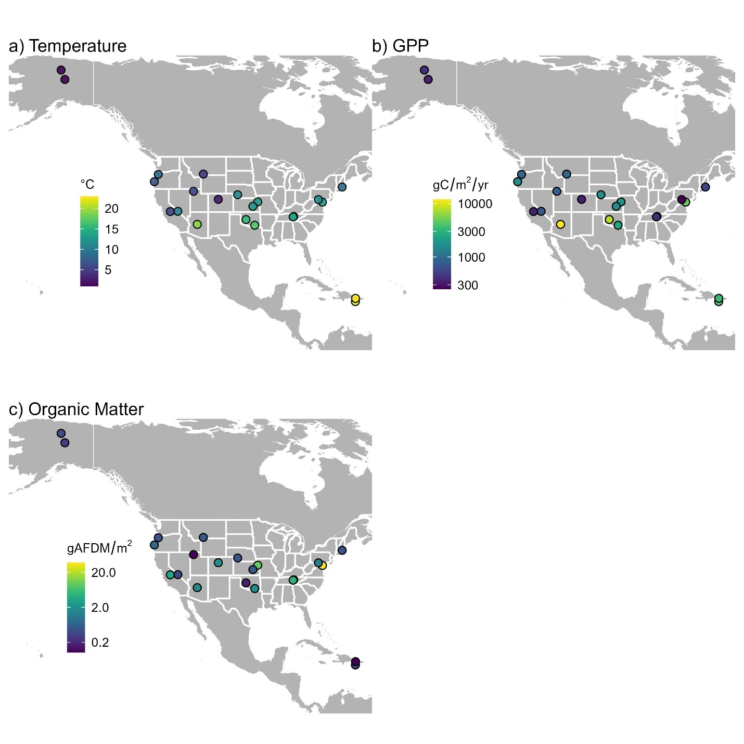

Figure X. Variation in temperature, gross primary production (GPP), and organic matter across NEON stream sites (n = 22). The points are jittered slightly to remove visual overlap. Values for temperature and GPP are annual means. Values for organic matter represent standing stocks averaged over 2-4 samples per site.

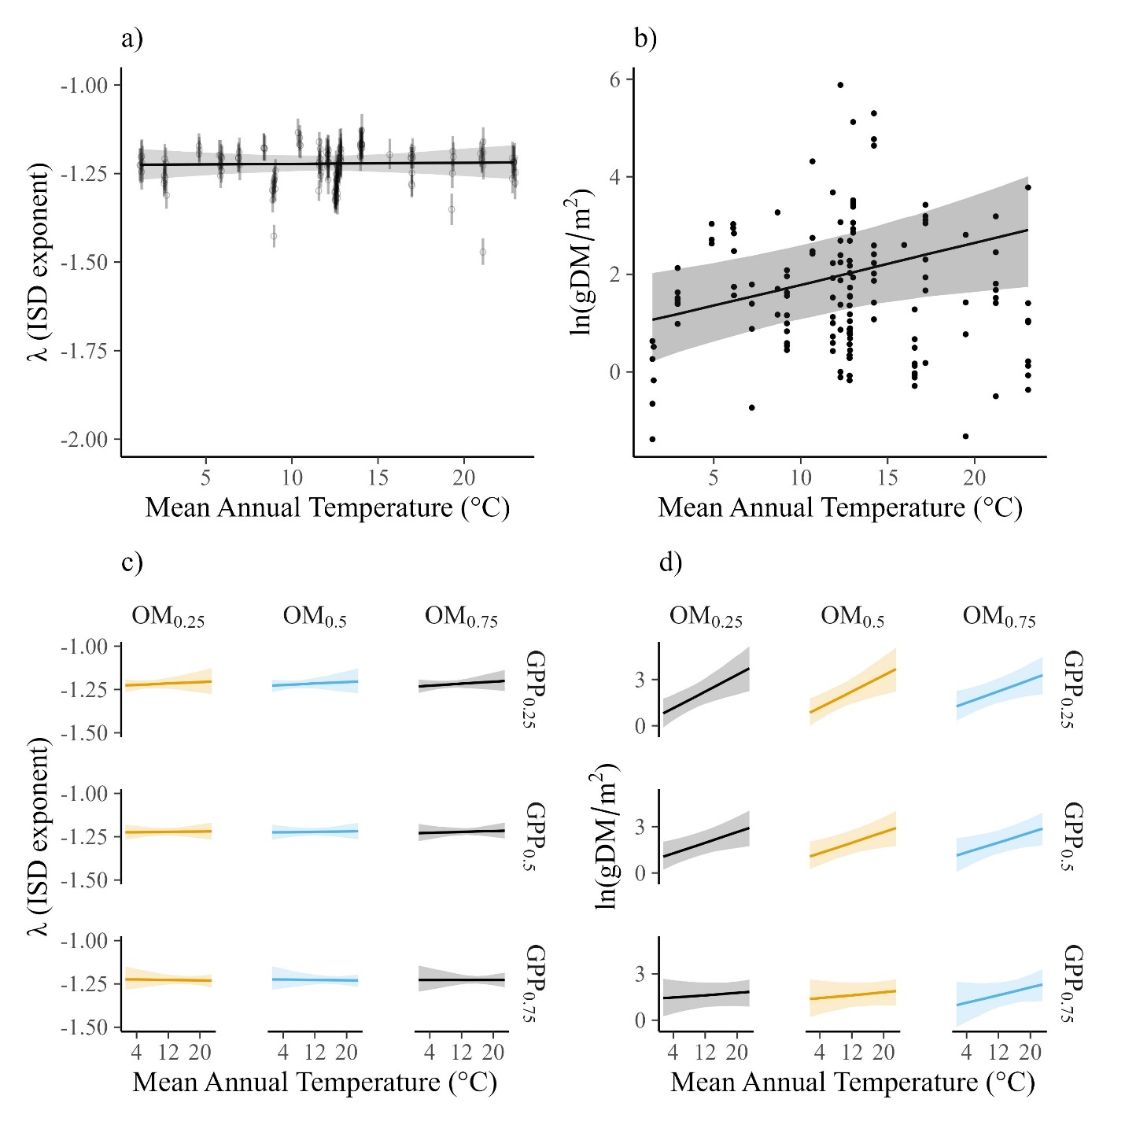

Figure X. Relationships of the ISD (a,c) and standing stock biomass (b,d) across mean annual stream temperature, mean annual gross primary production (GPP), and standing stock organic matter (OM). The top two panels (a,b) show the marginal relationship between ISD or standing stock biomass from models that include ln GPP, ln organic matter, temperature, and all 2 and 3-way interactions. The bottom panels (c,d) show the counterfactual predictions of the ISD and standing stock across the 25th, 50th, and 75th quantiles of ln organic matter and ln GPP.

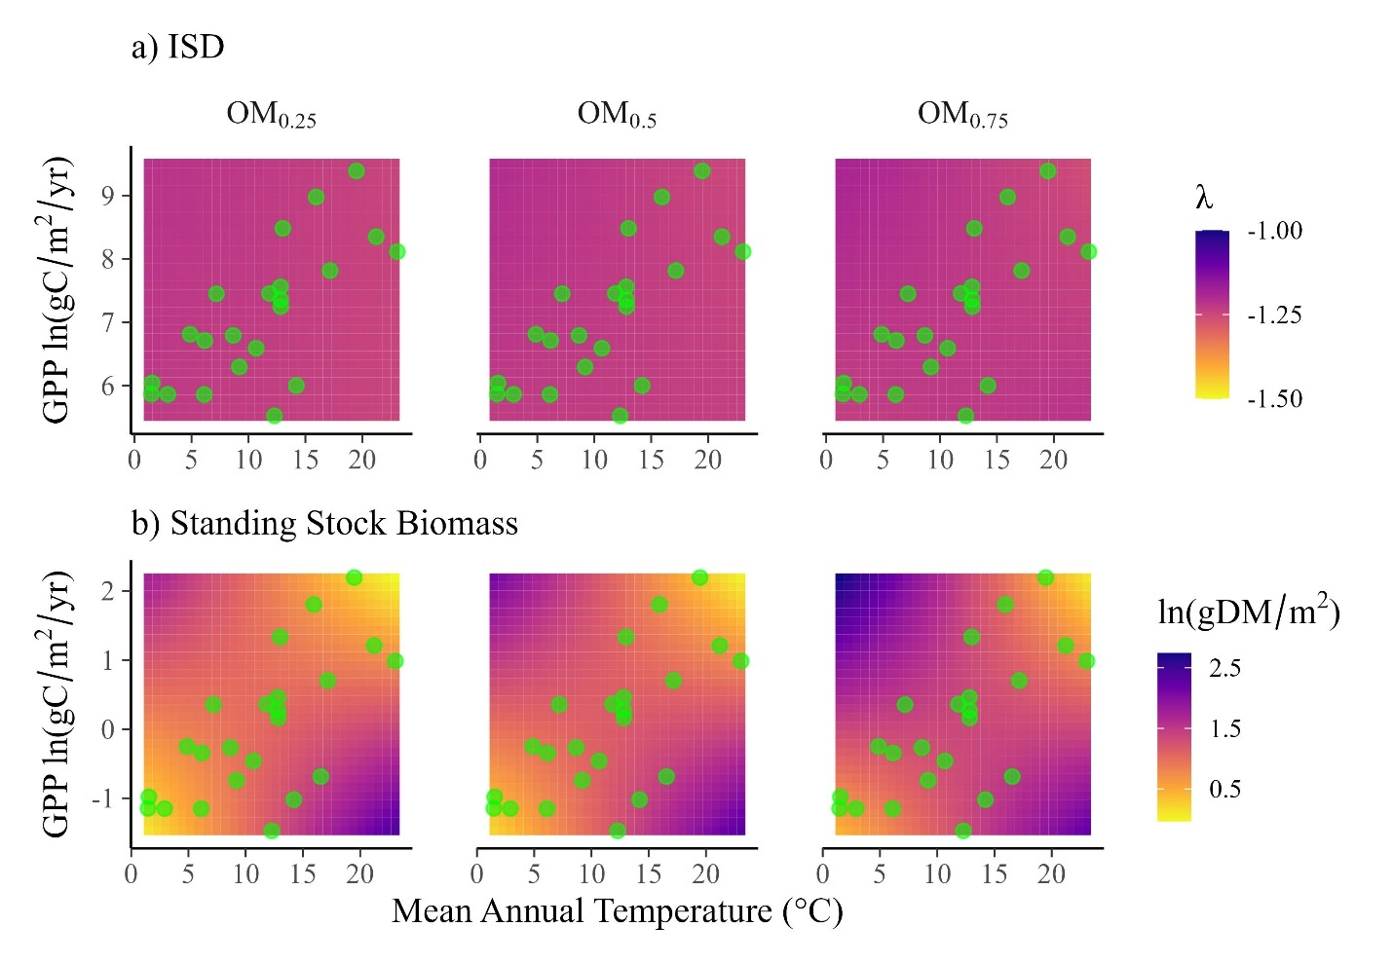

Figure X. Model predictions of the ISD exponent (a) and standing stock biomass (b) across continuous values of annual gross primary production (ln GPP) and mean annual stream temperature at three levels of standing stock organic matter (OM; 25th, 50th, and 75th quantiles). The dots show the corresponding values of ln GPP and mean annual stream temperature across the 22 NEON sites. The lack of color change in a) reflects the invariance of the ISD exponent to environmental conditions. By contrast, the color change in b) shows interactions with GPP, temperature, and organic matter (OM), but the strongest changes occur for environmental conditions that are not present in the NEON sites (e.g., high GPP/low temperature or low GPP/high temperature).

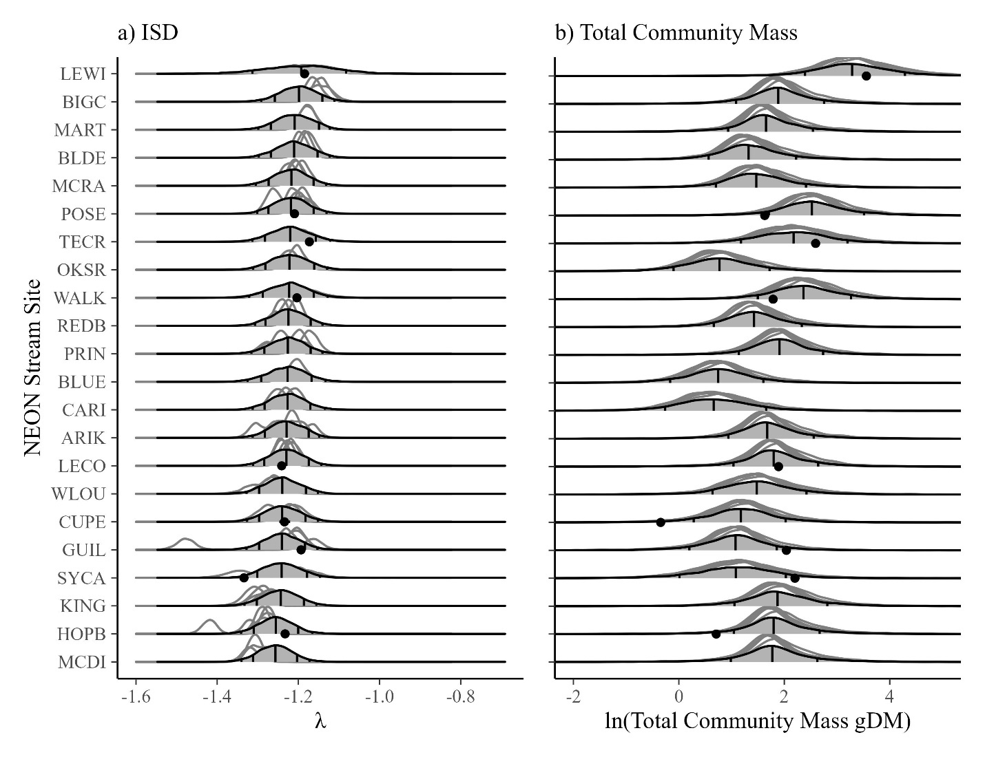

Figure X. Forecasts of ISD’s and total community biomass based on models trained on data from 2016 through 2021. Gray-filled densities show 2022 forecasts using the posterior predictive distribution, with vertical lines at the 50th, 75th, and 95th quantile (95th is difficult to see). The individual densities (unfilled) show sample-specific model predictions using varying intercepts. The dots are data collected in 2022. In each case where 2022 data are available, the observed values (dots) fall within the 95% prediction intervals of the forecasts.

|  |  |  |  |
| --- | --- | --- | --- |
| Table 1. Summaries of mean annual temperature (Temp, °C), mean annual gross primary production (GPP, gC/m2/y), and allochthonous organic matter input (gAFDM/m2) across the 22 streams sites in this study. | | | |
| Site | Temp | GPP | OM |
| CARI | 1 | 353 | 0.3 |
| OKSR | 1 | 420 | 0.4 |
| WLOU | 2 | 351 | 1.9 |
| BLDE | 4 | 907 | 0.5 |
| TECR | 6 | 350 | 3.5 |
| REDB | 6 | 821 | 0.1 |
| MCRA | 7 | 1719 | 0.7 |
| MART | 8 | 891 | 0.5 |
| HOPB | 9 | 541 | 0.5 |
| BIGC | 10 | 727 | 0.4 |
| ARIK | 12 | 1728 | 0.5 |
| POSE | 12 | 250 | 1.2 |
| KING | 12 | 1919 | 9.2 |
| MCDI | 13 | 1573 | 0.5 |
| LECO | 13 | 1402 | 0.3 |
| LEWI | 13 | 4828 | 37.7 |
| WALK | 14 | 403 | 4.6 |
| BLUE | 16 | 7925 | 0.2 |
| PRIN | 17 | 2479 | 2.0 |
| SYCA | 19 | 11957 | 1.8 |
| GUIL | 21 | 4235 | 0.3 |
| CUPE | 23 | 3344 | 0.1 |

**Tables (MAIN or SI)**

|  |  |  |  |  |  |
| --- | --- | --- | --- | --- | --- |
| Table 2. Fitted parameter values from models of the individual size distribution (ISD) and standing stock community biomass (dry mass). Parameters include the intercept (α), regression coefficients (β), varying intercepts (σx). The ISD model has a truncated pareto likelihood. The standing stock model has a Gaussian likelihood and hence also includes a parameter for the standard deviation (σ). Values summarize the mean and 95% Credible Intervals of the posterior distribution. | | | | | |
| Model | Parameter | Mean | Q2.5 | Q97.5 |
| ISD | α | -1.22 | -1.25 | -1.2 |
| ISD | βlogOM_s | 0 | -0.06 | 0.05 |
| ISD | βlogGPP_s | -0.01 | -0.03 | 0.02 |
| ISD | βTemp_s | 0.01 | -0.02 | 0.04 |
| ISD | βlogGPP_s x logOM_s | 0 | -0.04 | 0.05 |
| ISD | βlogOMs x Temp_s | 0.01 | -0.06 | 0.09 |
| ISD | βlogGPP_s x Temp_s | -0.01 | -0.03 | 0.02 |
| ISD | βlogOMs x Temp_s x logGPP_s | 0 | -0.07 | 0.07 |
| ISD | σsite | 0.02 | 0.01 | 0.04 |
| ISD | σyear | 0.004 | 0 | 0.02 |
| ISD | σsample | 0.04 | 0.04 | 0.05 |
|  |  |  |  |  |
| ln(Standing Stock Biomass) | α | 1.1 | 0.6 | 1.6 |
| ln(Standing Stock Biomass) | βlogOM_s | 0 | -0.5 | 0.6 |
| ln(Standing Stock Biomass) | βlogGPP_s | -0.3 | -0.5 | 0 |
| ln(Standing Stock Biomass) | βTemp_s | 0.3 | -0.1 | 0.7 |
| ln(Standing Stock Biomass) | βlogGPP_s x logOM_s | -0.2 | -0.7 | 0.2 |
| ln(Standing Stock Biomass) | βlogOMs x Temp_s | 0.2 | -1 | 1.3 |
| ln(Standing Stock Biomass) | βlogGPP_s x Temp_s | 0.1 | -0.3 | 0.4 |
| ln(Standing Stock Biomass) | βlogOMs x Temp_s x logGPP_s | 1.1 | 0.1 | 2.1 |
| ln(Standing Stock Biomass) | σ | 0.7 | 0.6 | 0.8 |
| ln(Standing Stock Biomass) | σyear | 0.1 | 0 | 0.5 |
| ln(Standing Stock Biomass) | σseason | 0.2 | 0 | 1 |

**SUPPLEMENTARY FIGURES**

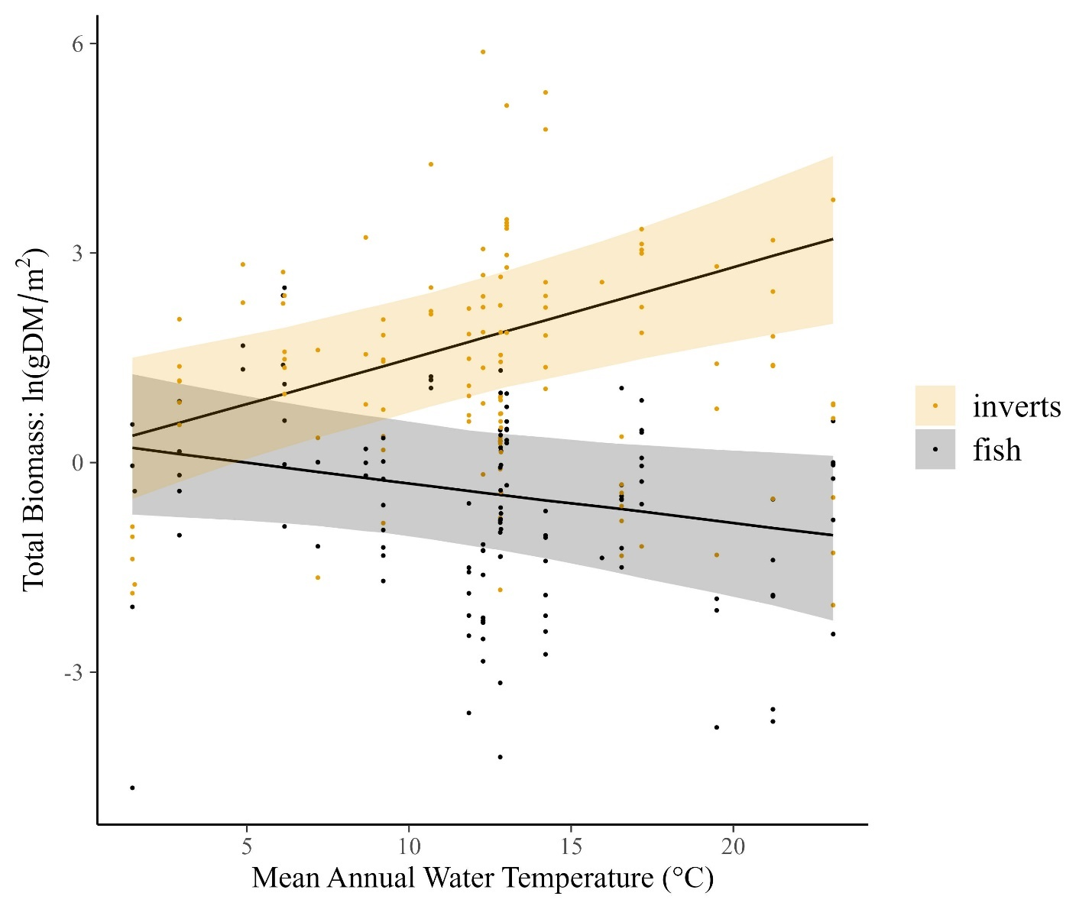

Figure SX. Marginal relationship between temperature and the standing stock of natural log-transformed total biomass of fish and invertebrates. Lines are posterior medians and shading is the 95% Credible intervals.

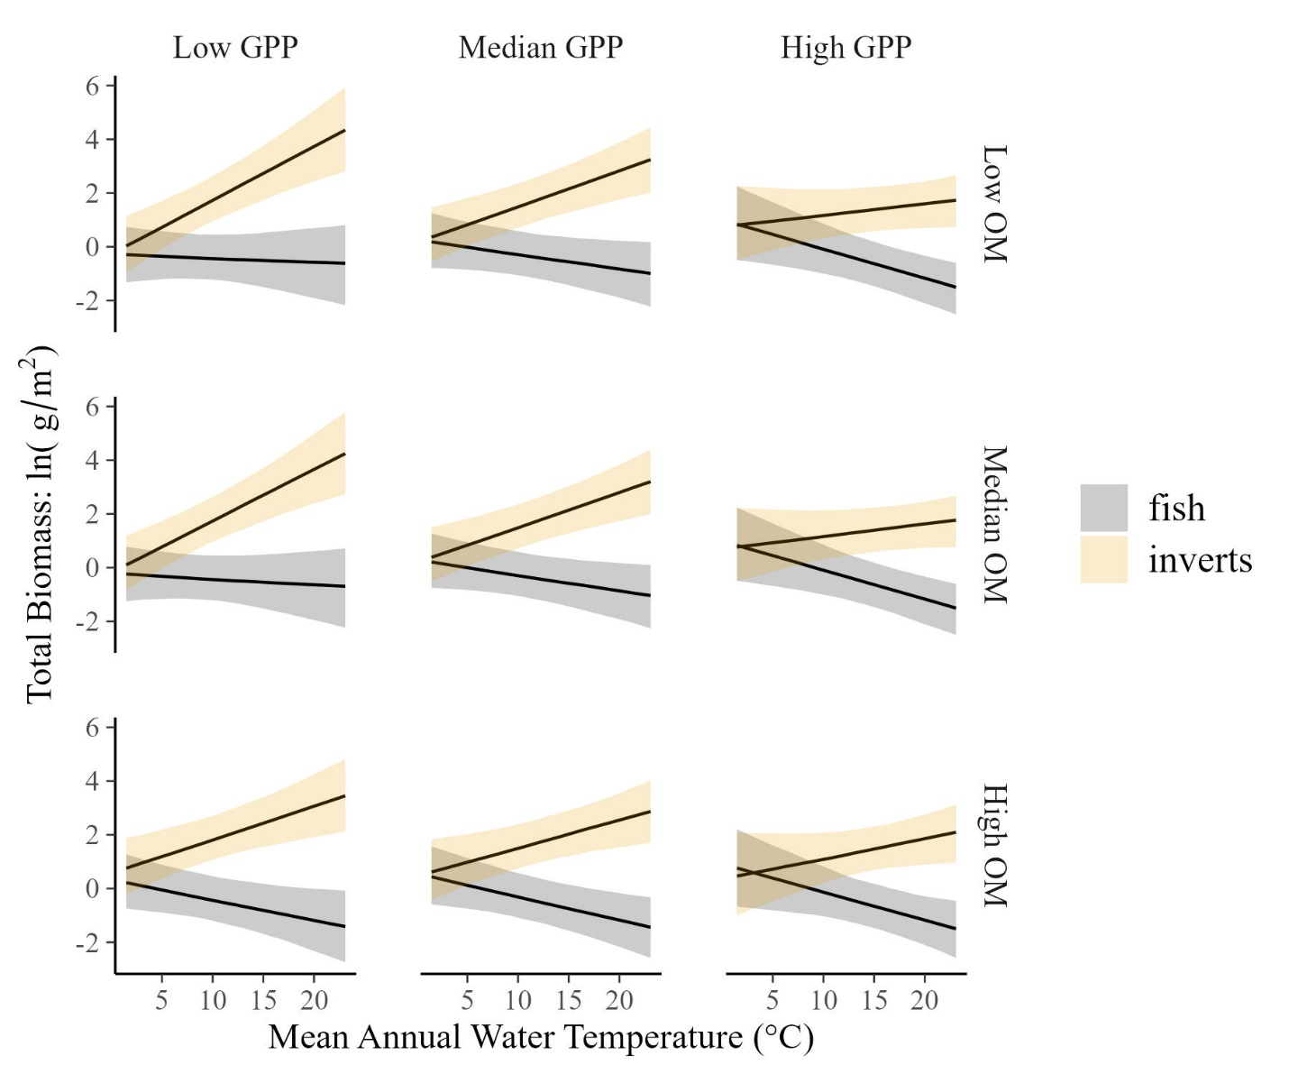

Figure SX. Interactions of the marginal relationship between temperature and the standing stock of natural log-transformed total biomass of fish and invertebrates across three values of resource supply (gross primary production and standing stock organic matter). Lines are posterior medians and shading is the 95% Credible intervals.

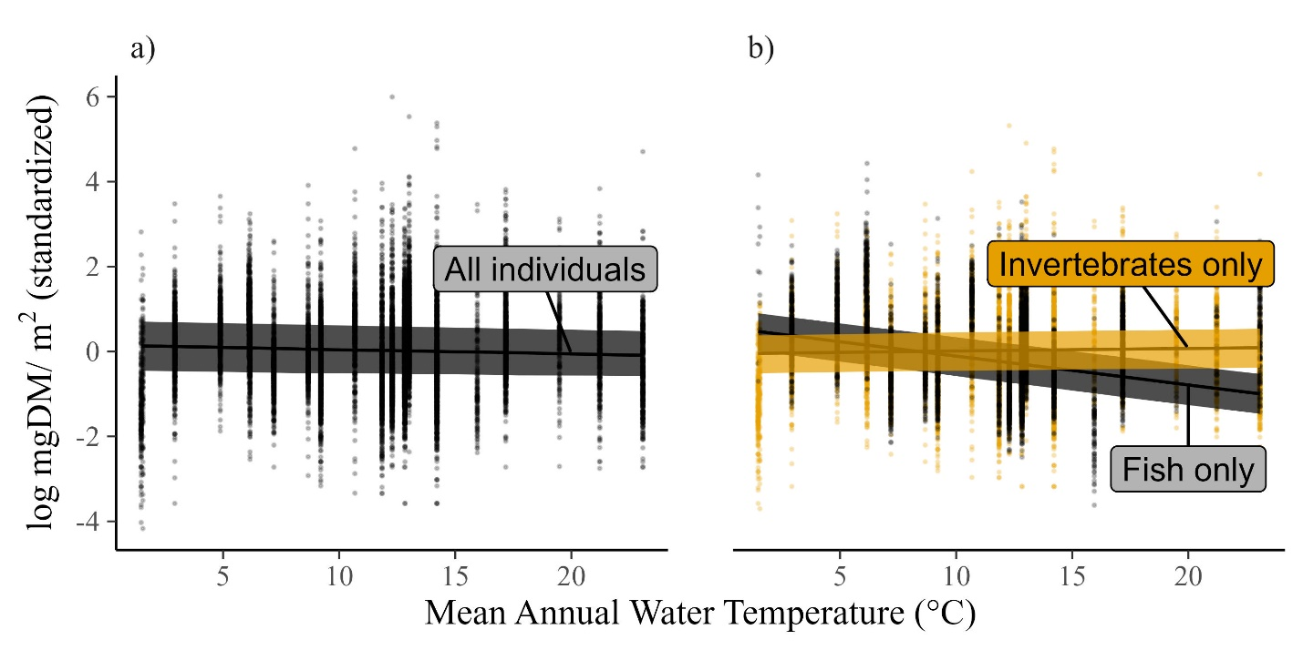

Figure SX. a) Mean individual body size did not decline with temperature when analyzed on all body sizes in the dataset. b) However, the overall lack of decline occurs due to opposing body size trends in fish and macroinvertebrates. Fish size declines with temperature, but invertebrate body size is constant. Data are weighted by mass-specific density, natural log transformed, and standardized to z-scores, with the mean and standard deviation being group-specific (i.e., inverts and fish are centered and standardized by their own mean and sd). This improves model fitting and allows comparison of the slopes, rather than the intercepts. In raw values, median individual fish body masses were 1000 times larger than macroinvertebrates (~2000 mgDM versus ~0.27 mgDM, respectively).